USDA AMS LOCAL FOOD PURCHASING AGREEMENT (LFPA)
Summary
February 1, 2022
Drafted by Kate Fitzegerald y Canepa
Fitzgerald•Canepa, LLC
USDA Agricultural Marketing Service (AMS https://www.ams.usda.gov) is dedicating up to $400M for cooperative agreements with states, tribal and territorial governments for the purchase of local food to be distributed to high need communities. Funding for the program comes from the American Rescue Plan passed last spring so this is a one-time injection of funds. Ideally, successful projects can be models for improvements to USDA’s procurement policies going forward.
The purpose of this program is to maintain and improve food and agricultural supply chain resiliency by:
- Providing an opportunity for States and Tribal Governments to strengthen their local and regional food system.
- Helping to support local and socially disadvantaged farmers/producers through building and expanding economic opportunities.
- Establishing and broadening partnerships with farmers/producers and the food distribution community, and local food networks, including non-profits to ensure distribution of fresh and nutritious foods in rural, remote, or underserved communities.
Process
USDA AMS has issued an RFA (see below) with an April 5, 2022 deadline. Each state has been allocated a share of the $400M based on a formula that includes the state’s poverty and unemployment rates. AMS will initially only allocate 60% of each state’s total funding to ensure that there are sufficient funds reserved for tribal communities in the state. (Allocations below)
For the first round of funding only one public, statewide agency from each state may apply. Most states are now in the process of deciding which agency will take the lead.
Note that only state agencies are permitted to apply for these funds and states must submit an application to receive them. States may subcontract program management to an NGO or private company and some states with low capacity have decided to do this.
If there are funds left over after the first round of applications AMS may consider making them available to local governments within each state.
The funding is in the form of a Cooperative Agreement which offers states more flexibility in program design than a standard AMS grant. AMS is expecting to approve a variety of approaches, is hoping that states and their partners will be creative. USDA will provide technical assistance and support to state agencies as needed.
Funding allocations will be for two years starting on the date that AMS signs a contract with the lead state agency.
RFA Key Points
- Funds are for the purchase of local, regional food defined as produced within the state or within 400 miles of the recipient agency.
- There is a priority for purchasing from socially disadvantaged farmers/producers.
- There is a desire to expand the standard distribution beyond TEFAP agencies and including schools, senior and early childhood centers, and other agencies but TEFAP recipient organizations are not excluded.
- States must have a plan to distribute food in rural, remote and underserved communities.
- The funding is initially available only to State, Tribal and Territorial Governments.
- There is no match requirement.
- Cooperative agreements are for two years from the date the contract is signed.
- State allocations are set but formula, only one agency may apply in each state and the process is non-competitive. AMS may subsequently consider applications from local governments if a state agency does not apply for its full allocation.
- State agencies may subcontract program implementation to other public, NGO or private companies.
- The application must show that the agency has established relationships with community groups, producers and distributors to be successful.
- The “predominance” of the budget must be used to procure food but,
- Funds may be used for program development, outreach, management, and
- The funds may be used to rent equipment for the term of the coop agreement but may not be used to purchase equipment.
- Funds must be used for a new program or one whose reach can be expanded with the money.
- Funds may be used for foodservice only if they do not supplant other public or private funds. For example, funds could be used to begin offering meals for low-income households at a community center but not to buy food for an existing congregate meal at a senior center or school.

Definitions
- Local – food produced in the state or within 400 miles of the agency receiving and distributing the food. The food must be sourced from an organization/company that has its headquarters in the state in which the food will be distributed.
- Socially disadvantaged farmers/producers are members of a group who have been subject to discrimination on the basis of race, color, national origin, age, disability, and, where applicable, sex, marital status, familial status, parental status, religion, sexual orientation, genetic information, political beliefs, reprisal, or because all or a part of an individual's income is derived from any public assistance program.

FAQ
- Food safety – Suppliers that serve the program must comply with their state and local food safety regulations.
- States may distribute food to be used in food service at schools and congregate feeding sites that serve low-income communities only if they do not supplant existing funding.
- The program is not restricted to fresh produce.
- Equipment may not be bought with program funds but may be rented for the duration of the contract.
- Food may be distributed through a variety of organizations including schools, senior centers, food pantries, recreation centers, etc.
- Cooperative agreements will be with state, territorial or Tribal governments but these agencies may partner with NGOs for the purchase and distribution of food.

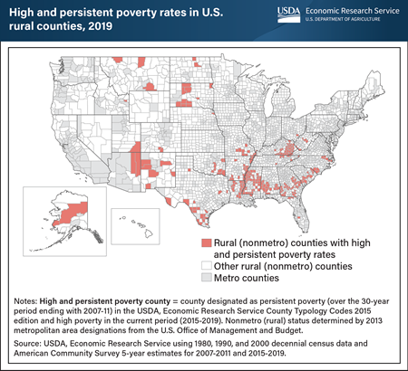

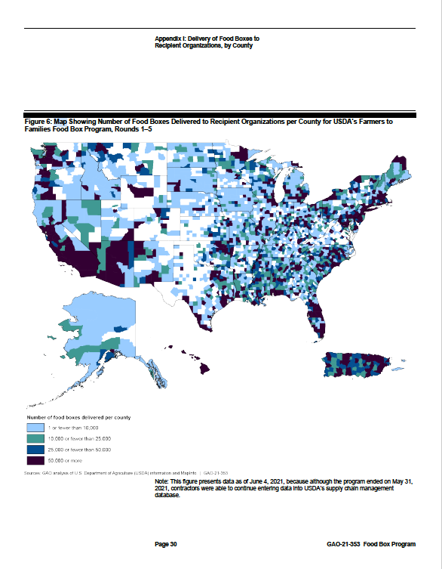

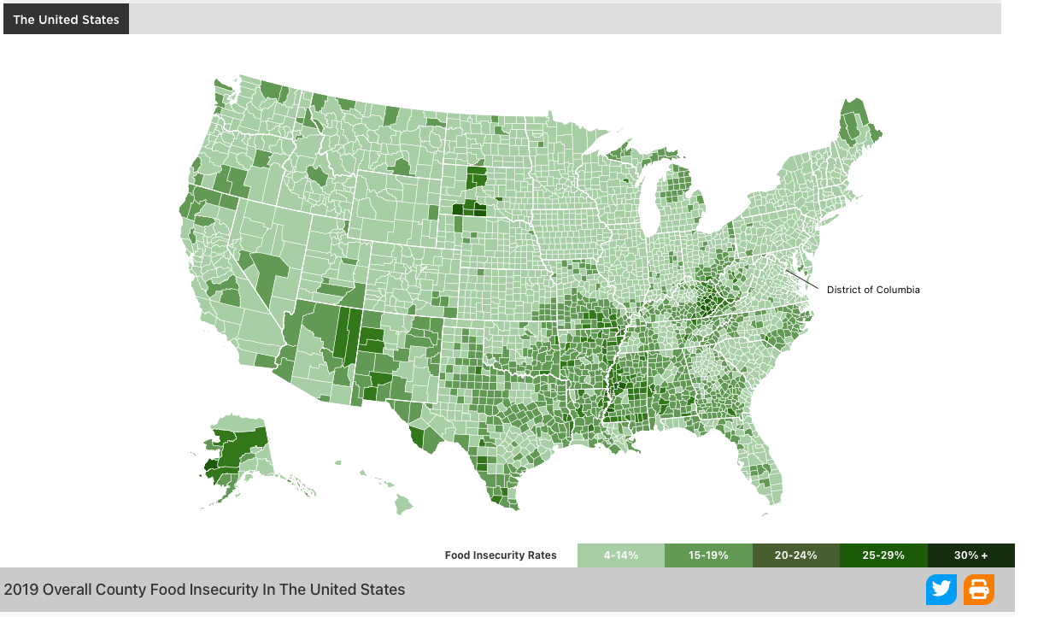

STATE | RFA TOTAL ALLOCATION  ($ millions) | 60% OF TOTAL ALLOCATION ($ millions)
Alabama | $5.9 | $3.54
Alaska | $0.9 | $0.54
Arizona | $8.7 | $5.22
Arkansas | $3.7 | $2.22
California | $51.3 | $30.78
Colorado | $6.5 | $3.9
Connecticut | $4.4 | $2.64
District of Columbia | $1.1 | $0.66
Delaware | $0.9 | $0.54
Florida | $24.8 | $14.88
Georgia | $12.5 | $7.5
Guam | $0.3 | $0.18
Hawai’i | $1.8 | $1.08
Idaho | $1.5 | $0.9
Illinois | $14.4 | $8.64
Indiana | $6.9 | $4.14
Iowa | $2.7 | $1.62
Kansas | $2.5 | $1.5
Kentucky | $5.5 | $3.3
Louisiana | $7.4 | $4.44
Maine | $1.3 | $0.78
Maryland | $6.1 | $3.66
Massachusetts | $7.5 | $4.5
Michigan | $11 | $6.6
Minnesota | $4.6 | $2.76
Mississippi | $4.7 | $2.82
Missouri | $6.1 | $3.66
Montana | $1 | $0.6
Nebraska | $1.6 | $0.96
Nevada | $4.4 | $2.64
New Hampshire | $0.9 | $0.54
New Jersey | $9.7 | $5.82
New Mexico | $3.3 | $1.98
New York | $26.7 | $16.02
North Carolina | $12.7 | $7.62
North Dakota | $0.7 | $0.42
Ohio | $13.5 | $8.1
Oklahoma | $4.4 | $2.64
Oregon | $4.4 | $2.64
Pennsylvania | $15.2 | $9.12
Rhode Island | $1.2 | $0.72
South Carolina | $6.1 | $3.66
South Dakota | $0.8 | $0.48
Tennessee | $8.2 | $4.92
Texas | $37.8 | $22.68
Utah | $2.2 | $1.32
Vermont | $0.5 | $0.3
Virginia | $8 | $4.8
Washington | $7.2 | $4.32
West Virginia | $2.4 | $1.44
Wisconsin | $4.9 | $2.94
Wyoming | $0.6 | $0.36
Virgin Islands | $0.2
Puerto Rico | $9.8
N Mariana Islands | $0.2

- AMS created an excellent website with full information here: https://www.ams.usda.gov/selling-food-to-usda/lfpacap
Note that other USDA agencies are offering grants loans and loan guarantees for supply chain development.

