Foundations of Value Chain Coordination Training
Participant Worksheet

Use this worksheet throughout the course to take notes and reflect on what you are learning.

Lesson 1: Foundations of Value Chain Coordination

💡Reflection Questions
Why are you here? What are you hoping to gain from this course? What are you trying to learn about VCC or your work?

Name three key principles or values that drive your work
1.
2.
3.

🔍Content Review
What are your a-ha moments from the recording?

What doesn’t make sense? What doesn’t resonate?

🗨️Discussion Questions
Who do you serve in your work? Who are you accountable to?

Where is power concentrated in the value chain that you’re working in? How does that impact the people that you serve?

Value chain coordination is a set of roles and activities that fosters connections to knowledge, skills, resources, and relationships between the individuals, businesses, communities, and the broader regional economies that make up a value chain. How does fostering connections to knowledge, skills, resources, and relationships help shift power in a value chain?

Lesson 2: Roles of Value Chain Coordination

🔍Content Review
What are your a-ha moments from the recording?

What doesn’t make sense? What doesn’t resonate?

💡Reflection Questions
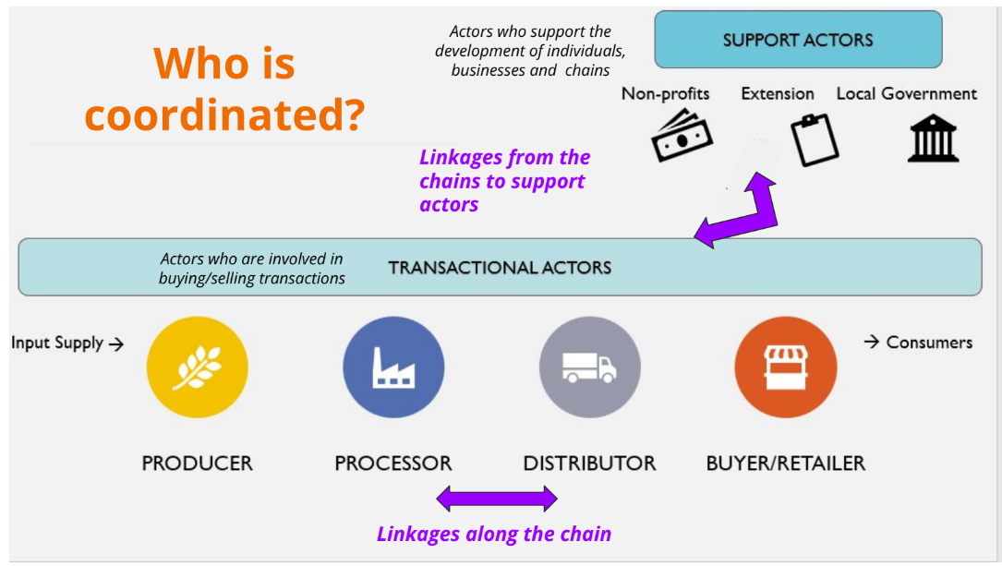
Are you primarily a support actor or a transactional actor?

Roles of Value Chain Coordination

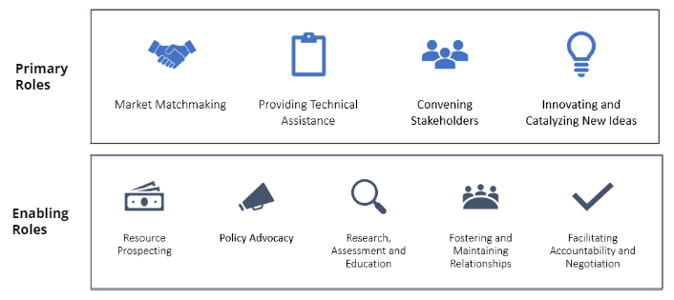

List the top three to four roles that you perform, with the first role being the role you do the most.
1.

2.

3.

4.

🗨️Discussion Questions
For that #1 role, what is your goal in performing this role? What do you hope to achieve?

Within this role, what are the biggest constraints that you face? What challenges make it hard to do this role?

What would help you overcome these constraints?

Lesson 3: Focus Strategies and Partnerships in Networks in VCC

🔍Content Review
What are your a-ha moments from the recordings for Lesson 3?

What doesn’t make sense? What doesn’t resonate?

💡Reflection Questions
What is the primary focus strategy that guides your current work?

(Remember: focus strategies are by product type, region, market channel, and values - and note that some might have many answers, and some might be blank.)

Values:
Product Type:
Region:
Market Channel:

Identifying Coordinating Partners: Looking at the list of VCC roles, write out who in your network is performing each role…

Market Matchmaking
Providing Technical Assistance
Convening Stakeholders
Innovating and Catalyzing New Ideas
Resource Prospecting
Policy Advocacy
Research Assessment and Education
Fostering and Maintaining Relationships
Facilitating Accountability and Negotiation

- What do you notice? Are there some roles that there are a lot of people doing? Where are there blanks?
- How do each of these partners advance or extend your work? (Consider the roles they perform)
- What is one next step you can take to fill those gaps where there are blanks? Where might new connections need to be formed?
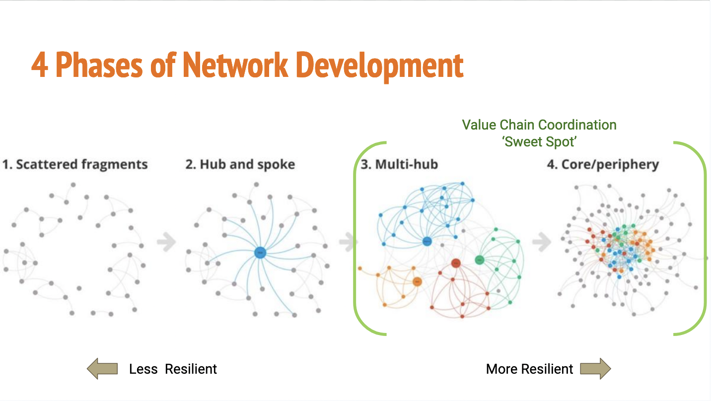
In your current VCC network, what stage of development would you say your food system is in? (Put a star next to the phase you’re at now.)
Reflect:
- What makes you say you're at the stage you identified?
- Who are the "hubs" or central organizers at this stage?
- What are the biggest challenges in this stage?
- What would help your network become more resilient?

🗨️Discussion Questions
Looking at the phases of network development, how do you think power may be more or less equitably distributed at these different phases? Why?
Where is power concentrated in your network?

Lesson 4: Visualizing Value Chains

🔍Content Review for Lesson 4
What are your a-ha moments from the recording?

What doesn’t make sense? What doesn’t resonate?

Context for Visualizing Value Chains
Reflect before launching down the path of creating a map of your value chain. What are the 2 main reasons you need a value chain map? (And if you can’t come up with an answer… you probably don’t need one yet!)

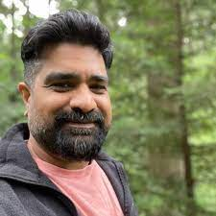
💡Reflection Questions
- What connections (or lack thereof) stand out to you from the map reviewed in the session?

  - What do you notice about the distribution of the dimension of power reflected in this map (i.e. the size of the nodes)?

- How would you describe the mix of transactional and support actors present on the map we reviewed in session?

  - What can you deduce about the breadth of VCC roles being performed?

  - Are any Primary Roles missing- and why might that matter given the challenges this value chain is facing?

🗨️ Discussion Question
Lesson 4 emphasized understanding and working with power in your context. “VCC practitioners need to understand not just how people are connected, but how power influences those connections, people, processes, and programs” When you read this statement, what questions or ideas come up in your own work?

Lesson 5: Evaluating value chains

🔍Content Review
What are your a-ha moments from the recording?

What doesn’t make sense? What doesn’t resonate?

🗨️Discussion Questions
What parts of the evaluation framework can fit easily into your evaluation work?

What parts of the evaluation framework would take more time to integrate into your work?

💡Reflection Questions
What data do you currently track, what data do you have about your VCC work?

Were the communities you aim to serve involved in determining what you currently track?

Write out how one of your overall goals for VCC work (your ‘why”) and how it connects to one of your values:

Selecting Metrics:
Review the list of metrics in the evaluation template - what is one metric that would help you measure progress towards your overall goal listed above?

What is one change you can make to your evaluation to start capturing this metric?

For any metric you select, consider how you can determine the impact on different populations. Who benefits the most, and who bears the most burden?

Closing Reflection

What is one change you’ll make to your Value Chain Coordination work based on what you have learned?

